Cryptotized Gameplay™ Official Guide Template
AMM's Simulated Strategies Hub™

NOTE : please fill in details about your roleplaying guide for all BOLDED inquiries below. Replace all light gray text with your own descriptions. Please don’t delete or modify any of the Copyright information in this templete….

Cover Page
Guide Title:
Game:
Version:
Author / Campaign Designer:
Guide Status:
- ☐ Draft
- ☐ Public Beta
- ☐ Final Release
Date:

Welcome
Briefly introduce your guide.
What experience are you trying to create?
Who is this guide for?

Legal Notice
- Unofficial fan project.
- Educational & entertainment purposes only.
- Not affiliated with or endorsed by the game's developers.
- Copyright belongs to their respective owners.
- Cryptotized Gameplay™ is the roleplaying framework created by AMM's Simulated Strategies Hub™.

Table of Contents
- Narrative
- Campaign Setup
- Character
- Economy & Assets
- Rules
- AI Prompt
- Gameplay
- Events
- Tips
- Final Thoughts

1. What is the Narrative?
Describe the overall story.
Example:
- What is happening?
- Why is your character here?
- What makes this roleplay unique?

2. Roleplay Difficulty

How much time, effort and experience should roleplayers expect when playing through your guide.

Setup Time:

When setting up your roleplay for the first time, how long does it take for preparations?

Estimated Play Time:

Is your roleplay continuous with no end or is there a time frame for completion. After completing the roleplay, are there any end game replayability?

Difficulty:

EASY / MEDIUM / HARD

Strategy Rating:

Does your roleplay have a lot of rules to follow? Something like an RTS game? Scale of 1 to 10.

Roleplay Rating:

Is your roleplay more narrative than action or using strategies? Is it more story based? Scale of 1 to 10.

Economy Complexity:

How tedious is your economy?

AI Dependency:

Low / Medium / High

Multiplayer Compatible:

Yes / No

Recommended Ai:

Which Ai models have you've tested and which one do you recommend? Was the conversation using a paid subscription or features?

3. Campaign Setup

Starting Location:

Starting Currency:

Starting Inventory:

Difficulty:

Optional Rules:

Victory Conditions:

Failure Conditions:

4. Character Profile
Character Name:
Occupation:
Faction:
Background:
Strengths:
Weaknesses:
Short-Term Goal:
Long-Term Goal:
Roleplaying Rules:

5. Economy & Assets

Do roleplayers initially start with any capital?

Starting Assets:

Properties:

Businesses:

Digital Assets (Optional)
Describe any simulated digital assets or unique collectible items that are part of your campaign.

6. Cryptotized Gameplay™ Rules
Explain your custom mechanics.
Examples:
- Property ownership
- Auctions
- Taxes
- Reputation
- AI decisions
- Simulated investments
- Trading rules
- Banking

7. AI Prompt
Paste the complete AI prompt here.
Explain:
- Which AI was used
- Any recommended settings
- Optional prompts

8. Gameplay Loop
Explain how players should play.
Example:
- Start campaign.
- Meet AI Game Master.
- Complete objectives.
- Manage assets.
- Update portfolio.
- Continue roleplay.

9. Random Events (Optional)
Create random encounters.
Example:
Roll | Event
1 | Property market crashes.
2 | Merchant appears.
3 | Festival increases tourism.
4 | Rare collectible discovered.
5 | Tax increase.
6 | Lucky investment opportunity.

10. Progress Tracker
Campaign Day:
Current Balance:
Properties Owned:
Businesses Owned:
Current Reputation:
Achievements:
Notes:

11. Tips
Helpful suggestions for players.
Example:
- Don't rush investments.
- Diversify your portfolio.
- Roleplay your decisions.
- Keep detailed notes.
- Have fun experimenting.

Community Feedback
What would you like players to test?
Examples:
- Economy balance
- AI responses
- Property values
- Gameplay pacing
- Difficulty

Changelog

Version 1.0
- Example: Initial Release.

Version 1.1
- Example: Added property system.

Version 1.2
- Example: Improved AI prompt.

Credits
Guide Author:
Contributors:
Special Thanks:

The End

Thank you for using this template and sharing your ideas with this wonderful community we are building together. We look forward to seeing your creative approach and how something that was once an idea becomes a household name in our growing repository. This community is for The Roleplayers and that will never change!

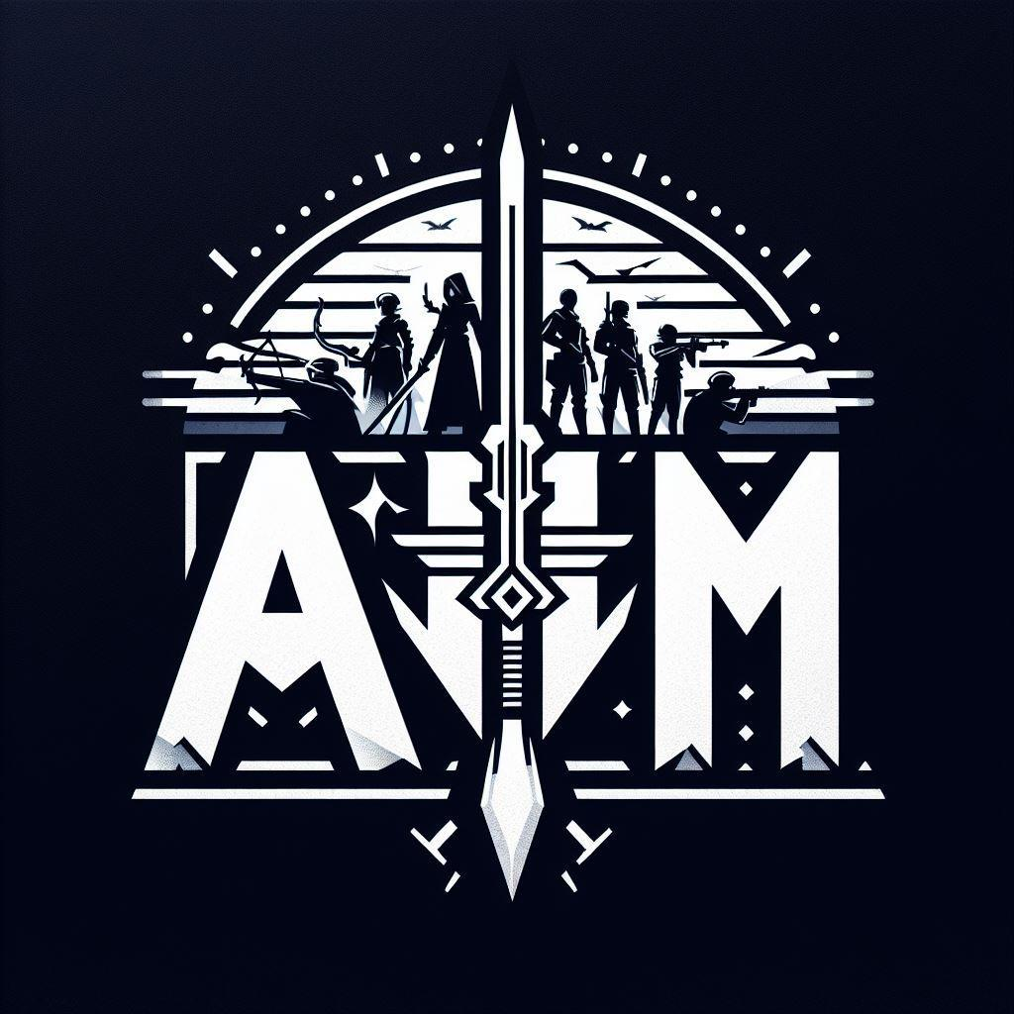

AMM's Simulated Strategies Hub™
Copyright © 2026 Angel Mendez. All Rights Reserved.

